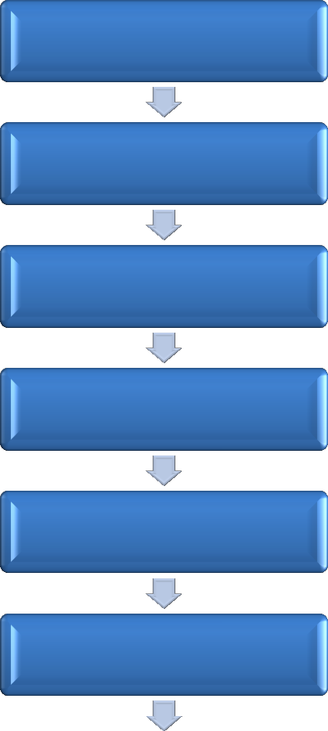

**Application**

**Research Aptitude**

**Test**

**Research Plan**

**Approval**

**Enrollment**

**Coursework**

**Semester wise**

**ProgressReview**

**Research Paper**

**Publications**

**Pre-Submission**

**Seminar**

**Thesis Submission**

**Thesis Evaluation**

**Oral** **Defence/Viva**

**Award of PhD Degree**